Energy Resources
In Canada, there are diverse and reliable sources of energy: oil, natural gas, hydroelectricity, coal, nuclear (uranium), solar, wind, tidal and biomass. Energy sources are of two types: nonrenewable and renewable.
- Nonrenewable cannot be replenished (made again) in a short period of time.
- Renewable energy sources can be replenished naturally.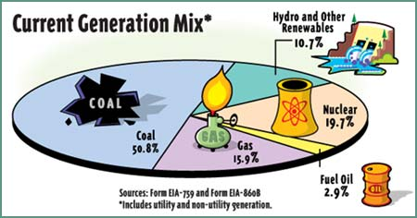
Nonrenewable: Nonrenewable energy sources come out of the ground as liquids, gases, and solids. Crude oil is the only commercial nonrenewable fuel that is naturally in liquid form. Crude oil is used to make gasoline, diesel fuel, and heating oil. All fossil fuels are nonrenewable. Coal, crude oil, and natural gas are all considered fossil fuels because they were formed from the buried remains of plants and animals that lived millions of years ago.

Renewable: Energy sources that can be replenished. Most renewable energy goes to producing electricity. Hydroelectricity is electricity generated by hydropower, which usually requires the potential energy of water stored behind a dam to drive a water turbine and generator. Solar power is energy from the sun. Solar energy is a serious source of energy because of the vast amounts of energy that is made freely available, if harnessed by modern technology. Wind has huge amounts of kinetic energy, and this can be transferred into electrical energy using wind turbines. The wind turns the blades which connects to a generator and makes electricity.

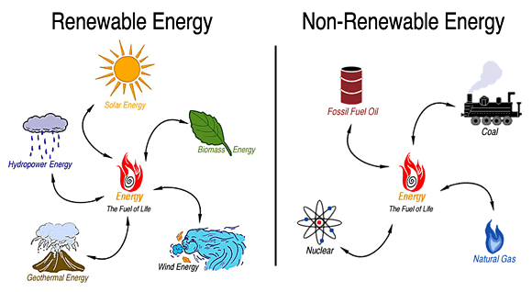

Why don't we use more renewable energy?
Renewable energy is more expensive to produce and to use than fossil fuel energy. Favorable renewable resources are often located in remote areas, and it can be expensive to build power lines from the renewable energy sources to the cities that need the electricity.
In addition, renewable sources are not always available: Clouds reduce electricity from solar power plants. Days with low wind reduce electricity from wind farms. Droughts reduce the water available for hydropower.

Transportation
Natural resources, like crude oil and natural gases, are found in completely different locations than where they are used.

Here are 4 ways to transport oil
- Marine oil tanker and barges are boats that can transport oil all around the world.
- Pipelines are long tubes used to transport oil from the wells to factories.
- Train Rail cars are another way to move crude oil across a landmass over the railway.
- Trucks

Advantages and Disadvantages of using Oil Pipelines
Advantage | Disadvantage
- They are made to transport liquids and gases. They are reliable and safer than other methods, and use less energy when doing so.  - It is cheaper to transport using pipelines  - Pipelines can be laid through difficult terrains as well as underwater. | - Finding land to build can be difficulty, and building pipelines can have a negative environmental impact  - If there is a leak it could cause environmental damage  - It is a lot of work to patrol, maintain, and secure the pipeline

Links
Eschool Energy: http://www.eschooltoday.com/energy/renewable-energy/solar-energy.html
AE Kids Renewable Energy: http://www.alliantenergykids.com/EnergyandTheEnvironment/RenewableEnergy/022403
Kids esdb: https://www.kids.esdb.bg/
Natural Resources Canada Thematic: http://www.nrcan.gc.ca/earth-sciences/geography/atlas-canada/selected-thematic-maps/16838

Videos
Sources of energy: https://www.youtube.com/watch?v=AsXxn83xeL4
Student Energy: https://www.studentenergy.org/
Renewable and Nonrenewable Resources: https://www.youtube.com/watch?v=Bh5lyOCUcRg
Kids Educ Different sources of energy: https://www.youtube.com/watch?v=wMOpMka6PJI
How energy is produced: https://www.youtube.com/watch?v=krP7pvcFlDY

Mining Resources
Mining is the extraction (removal) of minerals and metals from earth. Rocks are composed of minerals. Human societies have come to value particular elements and minerals more than others, for use as fuels, to make tools and chemicals, or to wear as jewellery.
Minerals and metals are the building blocks of the computers and smartphones we rely on, of the vehicles and public transit that get us places, of the buildings where we live and work, and of green technologies that help make the world a more sustainable place. Minerals are naturally-occurring geological formations, meaning they are not formed of animal or plant matter.

Canada ranks among the world's leading exporters of minerals. The search for mineral deposits was a major driving force in the country's development. When commercially significant deposits were found, towns sprang up at the sites.

Types of Mining
Shaft mining is very dangerous. They dig a mine shaft down into the earth until they find mineral deposits. The miners dig sideway shafts to dig out the minerals These shafts get very hot and it’s hard to breathe. Rocks fall and sometimes gas explodes. The deepest shaft mine is 2.4 miles deep in South Africa. | 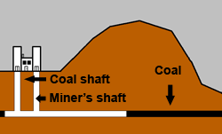
Open pit mines are simply big, open holes. Coal, copper and other minerals are dug out of the pits. Once the minerals or coal is gone, the pits are filled with trash and covered with soil. The biggest open pit mine is one mile deep, in Utah. | 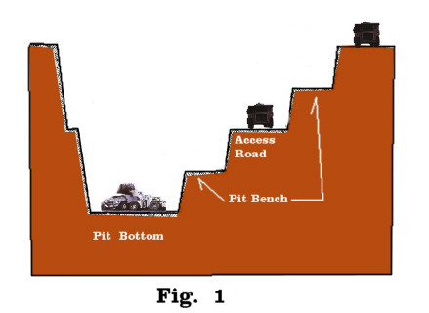
Quarrying is the process of cutting stone, usually out of a mountainside. Years ago, quarrymen used dynamite or hammers and wedges to split the rock off the mountain. Today, mechanized saws do the work. | 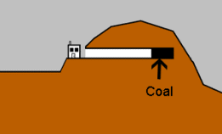

British Columbia Mining Resources
Copper is a natural metal. It absorbs heat very easily which is why we sometimes use it to make pots and pans for cooking. We use it in electrical wires too because electricity flows through it really easily. Used in: Pennies, Electrical wires, Water Pipes
Gold is shiny, soft and dense. It is also malleable, which means it can easily be beaten into thin sheets or other shapes. Gold is a good conductor of electricity and heat.
Zinc is a shiny bluish-white colored metal, while commercial grades of the metal usually have a dull finish to it. An important quality of zinc is its ability to resist corrosion and protect other metals. Half of all zinc produced today is used to strengthen steel. It is used to protect buildings, cars, nails, wire, pipes and more.
Silver is a soft, shiny metal that is a good conductor of electricity.In modern times silver is also used in dentistry, electronics, photography, mirrors
Lead is a soft, malleable, ductile (drawn out into a thin wire) and heavy metal. .Today, over half of the lead produced is used as electrodes in lead-acid car batteries. Its high density and resistance to corrosion makes it useful as the ballast keel of sailboats and as scuba diving weight belts.
Coal is made largely of carbon. Coal has long been burned to create electricity and heat. Coal is converted to electricity by being burned in a furnace with a boiler. The boiler water is heated until it becomes steam, with the steam then spinning turbines and generators to create the electricity

Environmental Concern: Mining is generally very destructive to the environment. It is one of the main causes of deforestation. In order to mine, trees and vegetation are cleared and burned. With the ground completely bare, large scale mining operations use huge bulldozers and excavators to extract the metals and minerals from the soil. In order to clear the extractions, they use chemicals such as cyanide, mercury, or methylmercury. These chemicals go through pipes and are often discharged into rivers, streams, bays, and oceans. This pollution contaminates all living organisms within the body of water and ultimately the people who depend on the fish for their main source of protein and their economic livelihood.

Links
Canadian Encyclopedia Resources: http://www.thecanadianencyclopedia.ca/en/article/mineral-resources/
Metal Facts: http://www.sciencekids.co.nz/sciencefacts/metals.html
Kids Mongabay Mining: http://kids.mongabay.com/lesson_plans/lisa_algee/mining.html#VHtyaPXwLhzzAqR8.99

Videos
Modern Mining: https://www.youtube.com/watch?v=62-yS0uXBb0
How Gold Mining Works: https://www.youtube.com/watch?v=zMOYOB3NCYY
Open Pit Mining: https://www.youtube.com/watch?v=FcTEcK_ZIws

Fishery Resources
Seafood is one of the most widely consumed proteins in the world today. Some populations get 20% of their food from the sea. This also means that the wild fish populations have been greatly over-fished in some areas to meet this demand.

Fish farming, which is more commonly known as Aquaculture, means that large amounts of fish are bred and raised for the sole purpose of being food. In fact, it's estimated that one of every four fish consumed was bred on a fish farm. It has become a very efficient way to produce food. The methods used are rapidly changing in fish farming, which is bringing more attention to the subject. Aquaculture is necessary for keeping up with the demand of a seafood-loving world and comes with an assortment of advantages and disadvantages.

Advantages of Aquaculture
1: Fish farming allows us to replenish the food fish supply at a faster rate than the oceans can produce it, allowing suppliers to keep up with demand. Fish farming brings a more steady supply of seafood into areas that may not normally have this type of access. It also helps to lower the price of seafood. In return, the over-fished areas of the oceans will have a chance to recover.
2. The aquaculture industry has created lots of jobs for people who live in poor areas where unemployment occurs. It provides a very secure and stable way for fisherman to earn a living. It also grants them more time at home, and a longer time frame of which they can harvest fish.
3. Seafood provides many key nutrients and vitamins to the human body. Seafood is loaded with protein, omega-3 fish oils and other nutrients that are highly healthy. Fish farming can increase the supply of fish available for these regions, fighting malnutrition.
4. Fish farms can be built in virtually any location. As long as there is a natural setting, an artificial setting can be created where the fish can be cared for just like any other form of livestock. The farms can be in the form of artificial ponds, enclosures within a natural setting and large tanks.

Disadvantages of Aquaculture
1. Fish farms consists of large amounts of fish in a single area. When these fish excrete waste or die, they're released into local water sources, polluting and contaminating them. Often, waste products such as eaten foods, feces as well as dead fish are flushed into the water supply. Large portions of the aquatic ecosystem have been destroyed in order to sustain fish farms.
2. Fish raised on farms need feed, with much of their feed consisting of fish meal. This fish meal consists of ground-up smaller fish usually caught in the open ocean. Unfortunately, the resources required to feed the fish can cost more money.
3. Because of the large numbers of fish contained in fish farms, they can be breeding grounds for bacteria, sea lice and various diseases. Hatchery fish are more susceptible to disease that they can then spread to wild fish. The fish are also treated with drugs in order to prevent sickness and disease. These are chemicals that not only affect the ecosystem, but also consumers health.
4. Farmed fish have a limited gene pool from which to work, which increases the chances of mutation. When hatchery fish that stray from hatcheries breed with wild fish, They can grow weaker and are less likely to survive. Fish that escape into the wild ecosystem can spread diseases.

Types of Fish Farming
Inland Pond Culture: Artificial ponds of about 20 acres in size and about 6-8ft deep.
Recirculating systems: A closed set of chambers where fish is kept in one and water treatment kept in another. It helps to control anything that can cause harm to the fish. It is an environmentally friendlier system because residue from the filters is can be disposed off in a responsible manner.
Open-net pen and Cage systems: Found offshore and in fresh water lakes. Mesh cages are installed in the water with the fish inside it. With high concentration of fish in the pens, waste, chemicals, parasites and diseases are often exchanged in the immediate water environments.

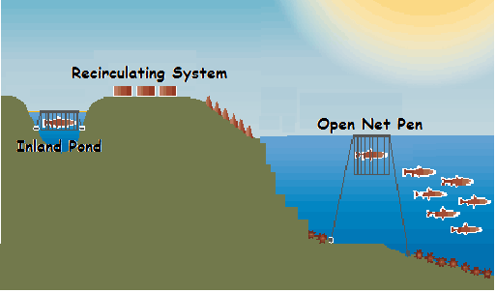
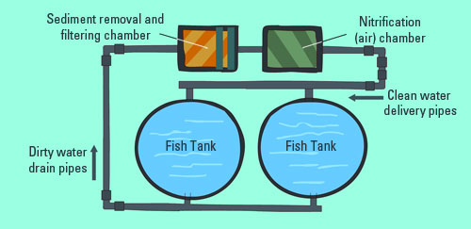
Fish farming can solve a lot of problems, but it may also cause new problems that need to be solved as well. By evaluated the pros and cons of fish farming, we can adapt and adjust as necessary to make sure all of our food needs are met in a safe way. With the issue surrounding the subject, it will never be easy to determine if the benefits of fish farming can outnumber its cons. With the pros and cons of fish farming stated, it can only help people understand both of its sides, but never really offer a resolution.

Links
E Schools: http://www.eschooltoday.com/aquaculture/what-is-aquaculture.html
National Aquaculture Association: http://thenaa.net/kids-corner

Videos
How Its Made: https://www.youtube.com/watch?v=Zj9UKh0qyYY&t=52s
Advantages of Aquaculture: https://www.youtube.com/watch?v=b33O13ZXs8I
Curious Kids: https://www.youtube.com/watch?v=pEwwD4Rlmww

Forestry Resources
Environmental activists consider forests as one of the top 5 natural resources on earth. Forestry is the science and practice of caring for forests. Both the meaning and practice of forestry in Canada have evolved over time. Two-thirds of BC’s land base is covered in trees. Many types of wood used for furniture, flooring, and construction are harvested from Canadian forests. This is done through logging.

What is Logging?
Logging involves cutting trees for sale as timber or pulp. The timber is used to build homes and furniture, and the pulp is used to make paper and paper products. Logging is generally categorized into two categories: selective, clear-cutting, and strip cutting.
Selective logging: Loggers choose only wood that is highly valued.
Clear-cutting: Loggers cut all of the trees down in an area, thus clearing the forest.
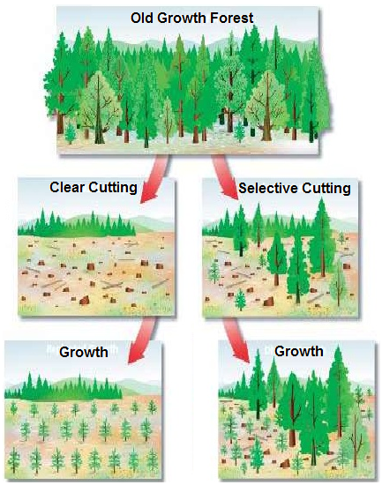
Selective logging can be very damaging to the surrounding trees which are not selected for logging. The heavy equipment used to cut the selected trees often damages the surrounding trees. It is estimated that 40% die from just one tree that is selectively logged. With selective logging, the largest trees are taken which means less seeds are spread. The trees remaining often shade seedlings (small plants), and they do not get the sunlight needed to grow and eventually become trees.

Clear Cutting is damaging to a forest because when all of the trees are removed, the soil loses its nutrients and becomes barren. Clear-cutting is a leading case of deforestation, as there are less seeds being spread. If new seedlings are plant, they are exposed to an equal and uniform amount of light. This equal amount of sunlight helps the young plants to grow and eventually become trees.

Logging is needed to provide building materials for houses, pulp for making paper, and many other things we use daily. Unfortunately with logging we lose many of our forests, some never growing back again. Logging uses large machinery, which causes air pollution. Animals are affected by losing their habitat. With less trees we also have less oxygen and more carbon dioxide in the environment. There are benefits to using both selective and clear cutting practices. As well as another more environmentally friendly practice.
Strip Cutting: Clear-cutting of thin strips of forests allows the forest to regenerate faster. This type of logging is designed to mimic or copy the natural succession (re-growth) of a rainforest.

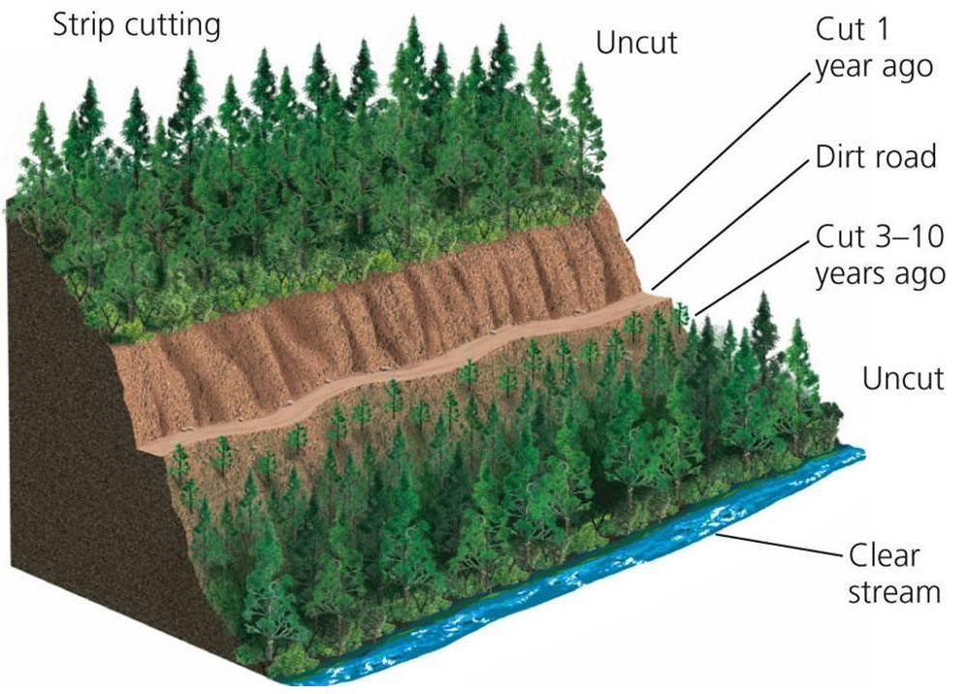
In all approaches, there are usually very strict rules and consequences with the way resources are extracted from that forest. It is usually enforced by laws, hefty fines and effective monitoring efforts. In recent time, the use of technology is helping authorities see more about what is going on in the forest.

Deforestation is when forests are cut down and the area is permanently cleared for another use. Forests are cleared for a number of reasons. There are two main reasons for deforestation: timber production and food production. Other reasons include mining and oil extraction. The most obvious reason for deforestation is to obtain wood. A large amount of deforestation occurs as a result of trees being chopped down for timber (logging). Trees that produce the strong timber known as ‘hardwood’ are felled to produce timber for building houses and other buildings. Timber is also used in paper production.

Deforestation can cause:
- Soil erosion (which can cause floods and landslides).
- Droughts (when an area becomes too dry due to lack of rain)
- Lack of biodiversity (the number of different species in an area becomes smaller)
- Habitat loss (animals and plants lose their homes)
- Climate change. Deforestation may contribute to global climate change.

Links
Learn Forestry: http://www.learnforestry.com/index.html
E School Forestry: http://eschooltoday.com/forests/forest-preservation-tips-for-kids.html
Canadian Encyclopedia Forestry History: http://www.thecanadianencyclopedia.ca/en/article/forestry/

Video
The Miracle Resource: https://www.youtube.com/watch?v=dzuEQ6QpMxY
Forest Clear Cutting: https://www.youtube.com/watch?v=zYcrJu9bJwM
Clear Cutting: https://www.youtube.com/watch?v=Ed7MRS7l-NU
Forest Harvesting: https://www.youtube.com/watch?v=1kfa4jYkq9k

